Configuring TCP/IP Protocol

1-1view the installed networking components and protocols:
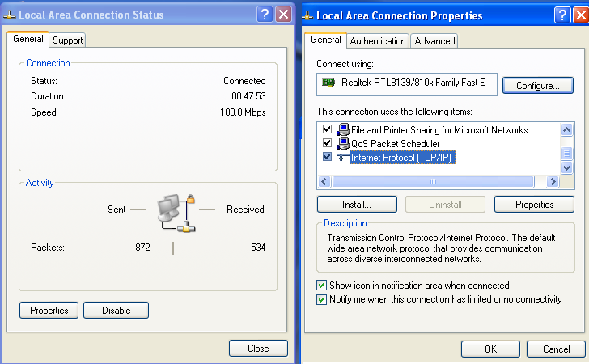

- to see tcp/ip properties ,choose it then click properties
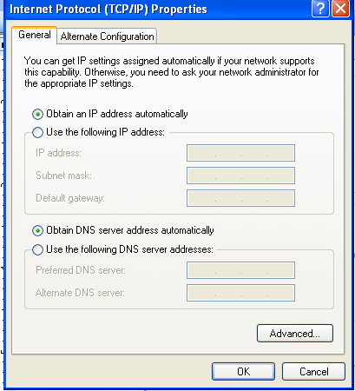
In this window u can obtain your ip auto or can put your static ip

1-2 view tcp/ip configuration
Start →program→accessories→ cmd
>ipconfig :////////// give detail on your network settings
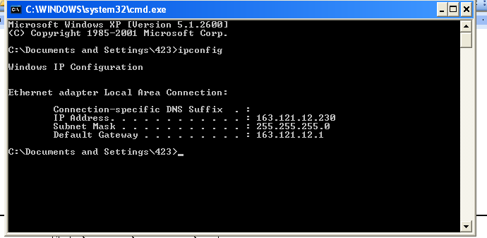

>ipconfig /all
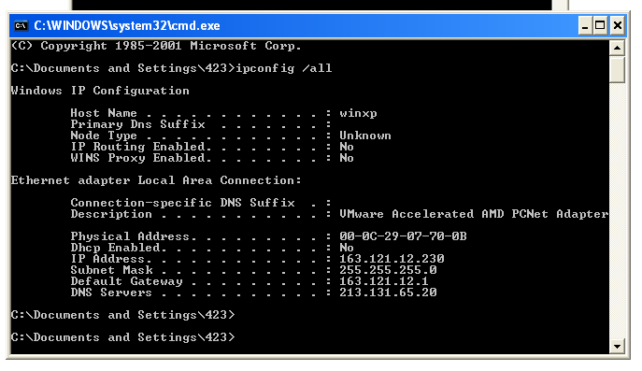
>ipconfig /renew ////////request anew ipfrom dhcp
>ipconfig /release

Dealing with FTP protocol

We need to have : * ftp server
- user account
- homedirectory
- permission
bullet proof ftp server :
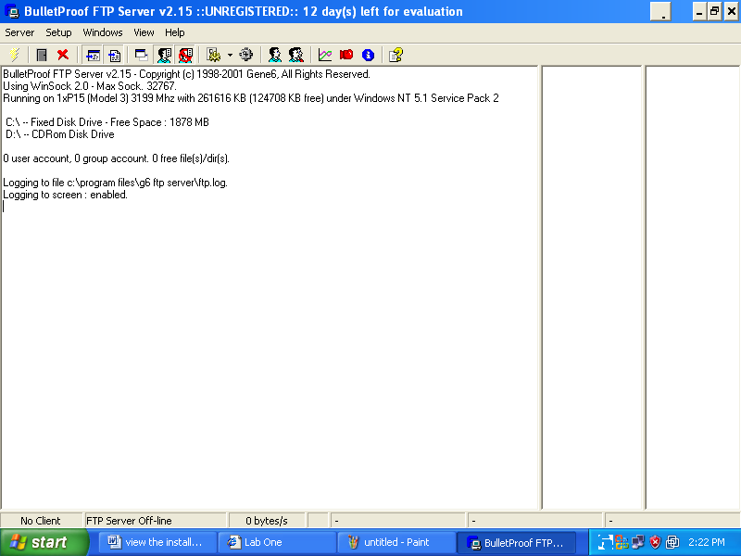
Add user account
Setup→account
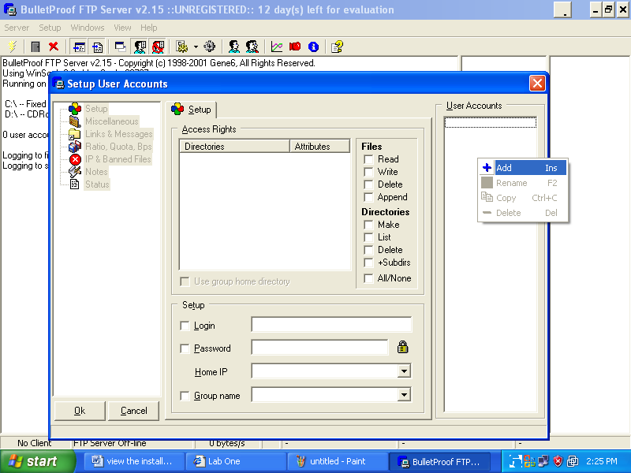

* ftp client
1)windows builtin cmd
- ftp >open ip
enter username and password
- get filename /// download file& save in the current directory
- mget filename1 filename2 /////download multipfile
- put file name
- hash // to see progress bar during process of download
- disconnect //close session
- bye // close ftp service

2)internet explorer
ftp:\\ip
or ftp:\\ip:port no
copy con file name /////// to write any thing and save it in file on server

3) third party program (cute ftp client )

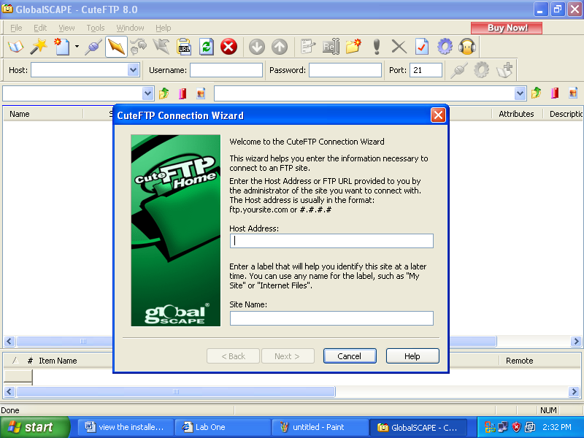

// host address : ip of ftp server
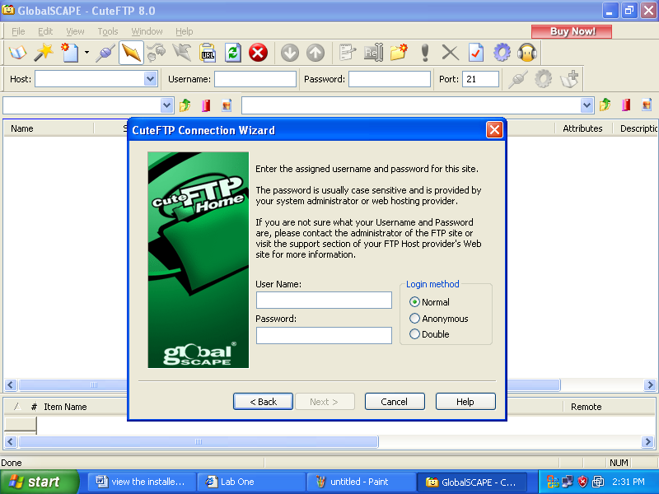

///user name and password of client which created on server

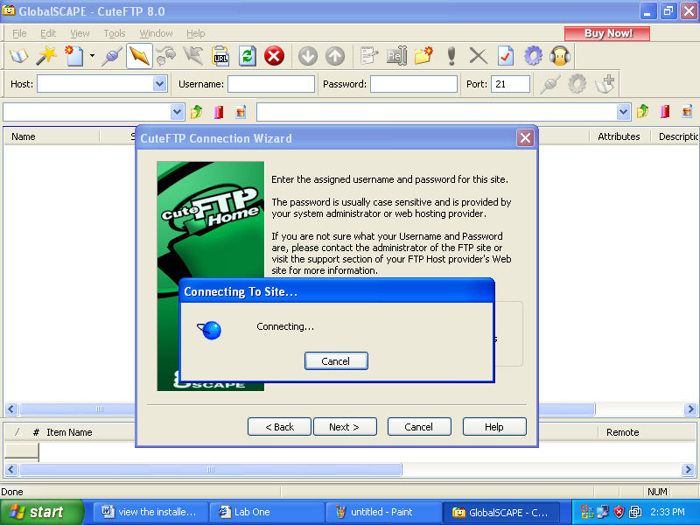
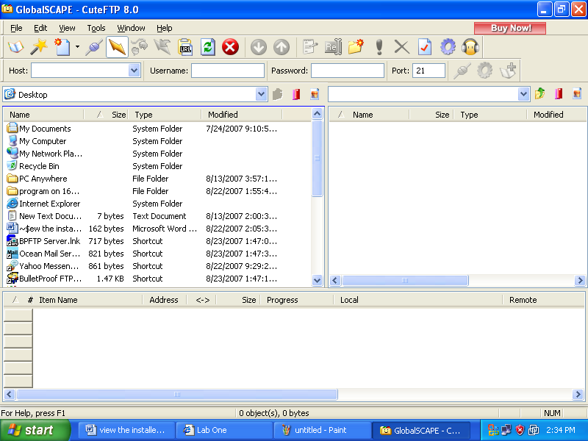
Drag & drop from server to your desktop

Using Telnet
Server : controlpanel → administratortools → services →telnet (enable)

Client : 1)cmd → telnet ip
Username & password
Or 2)internet explorer write telnet :\\ip
Dealing with DNS
- “hosts” file C:\Windows\System32\drivers\etc\ hosts
- "nslookup" tool to get IP(s) of any website
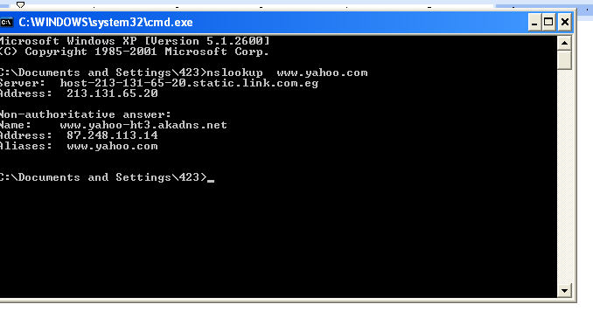
Dealing with Electronic Mail Service
Email can be :
webbased :like yahoo, hotmail
access by http ///IE
nonwebbased : like r@iti.net.eg
access by outlook express

IMAP: Mail stays on server, accessed remotely, normally needs to be deleted manually.
POP3: "Store and Forward" technology, stays on POP3 server until downloaded to client program, then normally auto-deleted from server

SMTP: used for communication between mail servers,
Client normally sends direct to SMTP server

Using Remote Administration

1)Using Windows Built-in Remote Desktop
